**WRITTEN TEST**

**Fiqky Akbar Widya Mukti**

1. JavaScript framework is a skeleton used to create or develop applications and software using the JavaScript programming language. Unlike normal JavaScript code, frameworks provide us with a skeleton and help organize files when building websites. Since this is a framework, the framework has rules written that may differ from the vanilla version of JavaScript. Currently popular frameworks are NEXT js, Vue js, Angular, and Svelte. Examples of writing rules can be found in NEXT js with built in code rules for routing, and the data fetching process also has write rules.

Vue js is one of the most popular frameworks in JavaScript for developing a website in the form of a single page application. Writing syntax in Vue tends to be shorter than in Angular or React js. This is why Vue js has become one of the most popular JavaScript frameworks today. Vue js still implements client-side rendering, but with Nuxt js as a framework built on top of Vue js, you can do server-side rendering just like NEXT js.

1. Ellipsis means a substitute sign. In this context, the ellipsis is a substitute for the end of a limited short description. Ellipsis ended by a "..." at the end of the sentence. set text-overflow to ellipsis to apply like bellow :

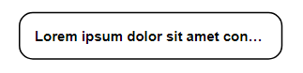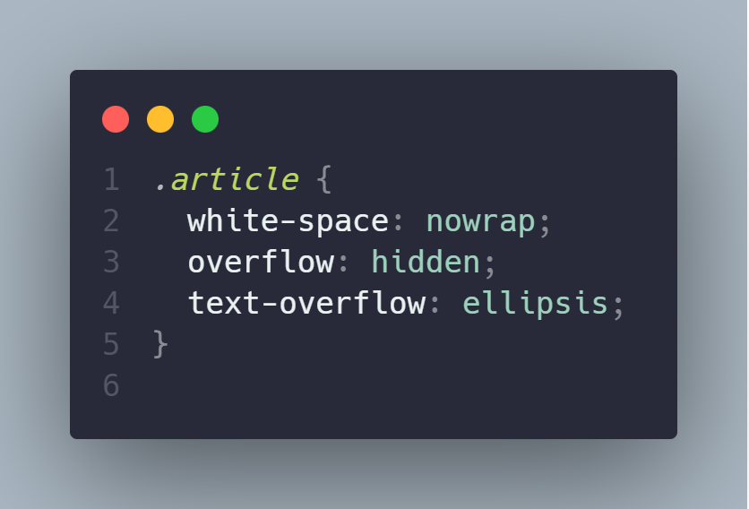

3a. @keyframes are rules for describing animation of elements in CSS in the form of movement or change of elements.With the animation in CSS, we can easily manage and make a movement or change of elements. @keyframes doesn't use JavaScript, so using @keyframes doesn't slow down a website performance. @keyframes need an Identifier of the animation to run. It should contain at least the animation name and duration of the animation.

3b. animation-name: The identifier name of the created animation that will be placed after @keyframes. animation-name is also connected with the HTML tag element.

3c. animation-time: How long the animation takes from start to finish. Animation time written in seconds.

3d. animation-iteration: Specifies how often to run the animation. You can also set it to infinity.

3e. animation-direction: The direction of the animation to run on the element. As another example where the animation returns to the initial state after the animation is complete

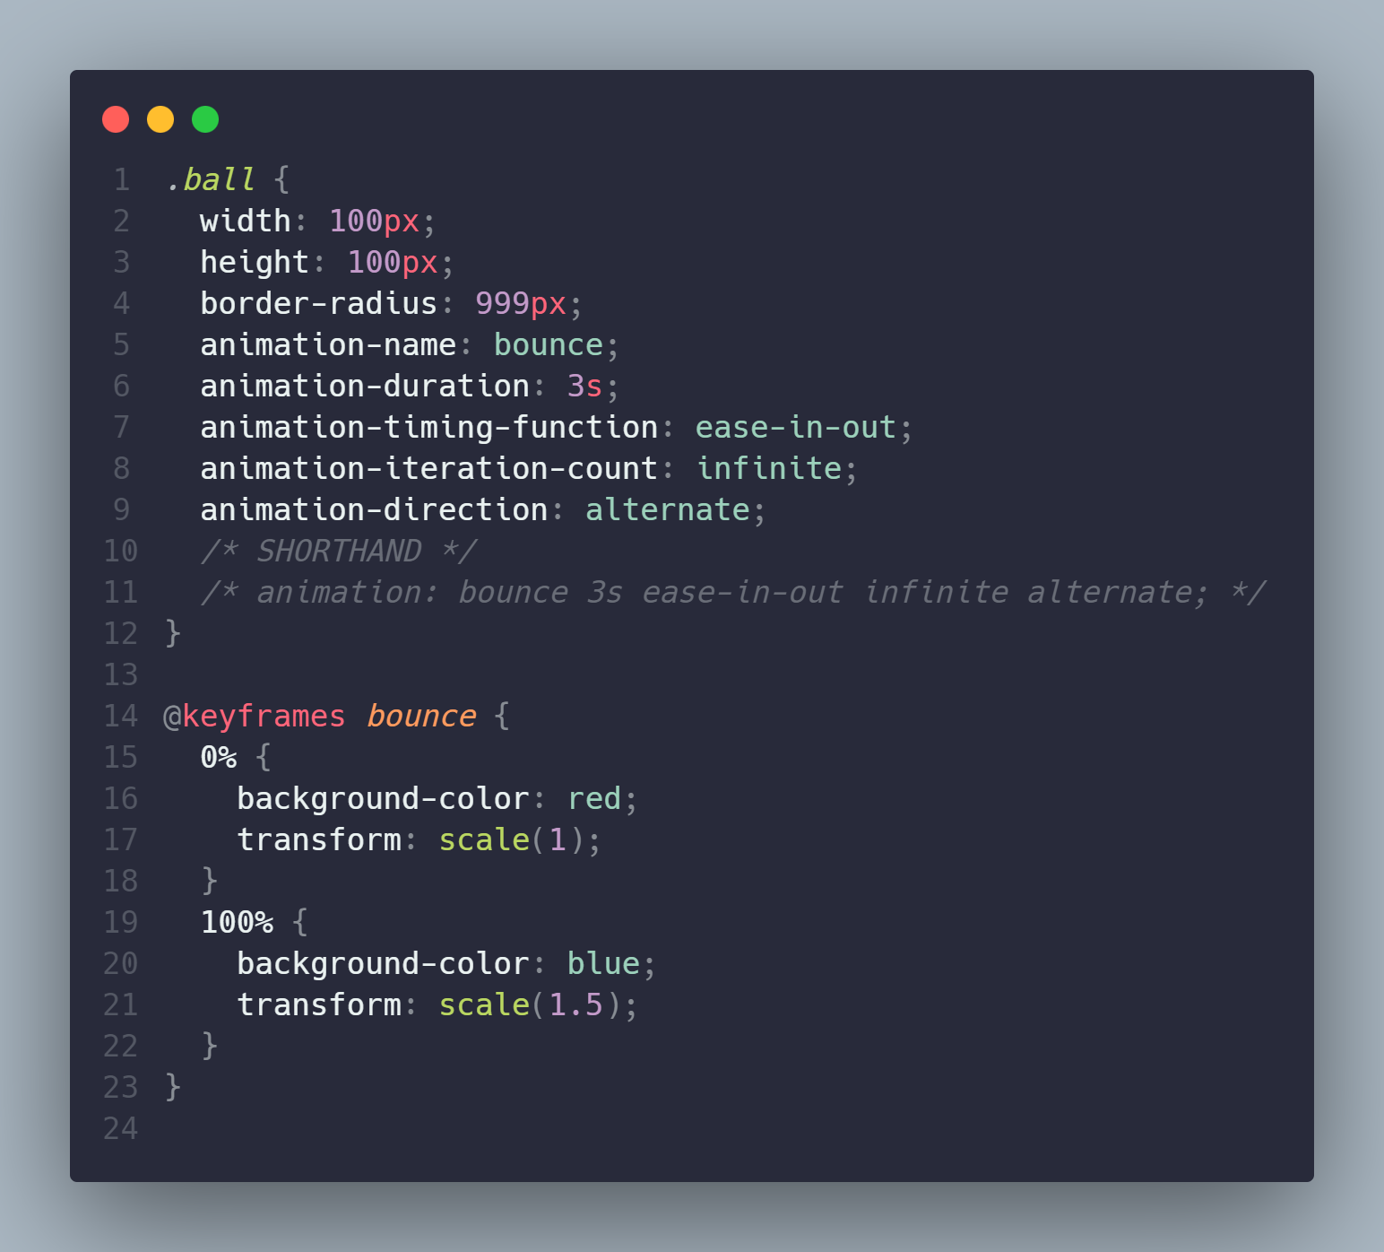

The image above is an example of @keyframes. The "bounce" identifier in the animation-name on line 5 refers to @keyframe on line 14. The animation-duration on line 6 sets the animation duration to 3 seconds. The animation speed setting is set in the animation-timing-function on line 7. Animation loop is set to infinite using animation-iteration-count on line 8. and the animation direction uses animation-direction which is an alternate, i.e. the animation returns to the initial animation after the animation finishes on line 9. On line 15, the animation starts with a red background color and a scale of 1 and runs until the background color changes to blue and the div element is 1.5 times its size.

1. Lazy Loading Images is a web development technique that delays the loading of images on a page until they are actually required, as opposed to loading them immediately. These techniques improve performance by lowering the number of images that must be loaded at the start of the page.
2. Here are some git commands with each function explained:

* git init : Git command to initialize git to create a new repository.
* git add : Git command to add files to index.
* git commit : Git command to commit changes to head. Note that any changes that are committed will not go directly to the remote repository.
* git push : Git command to send changes to the master branch of the remote repository that corresponds to your working directory. For example:
* git status : Git command to display a list of changed files along with the files you want to add or commit.
* git clone : Git command to copy a repository to local
* git merge : Git command to merge child branch into parent branch
* git checkout : Git command to move to another branch
* git branch : Git command to see lists of branches
* git pull : Git command to merge all changes in the remote repository to the local directory